Main Conference Theme "Health Promotion in Digital Nepal: Harnessing Eastern Wisdom, Healthy Settings, and Innovation"

Background & Rationale
- Health promotion is the process of enabling people to increase control over and improve their health.— WHO, Ottawa Charter (1986)
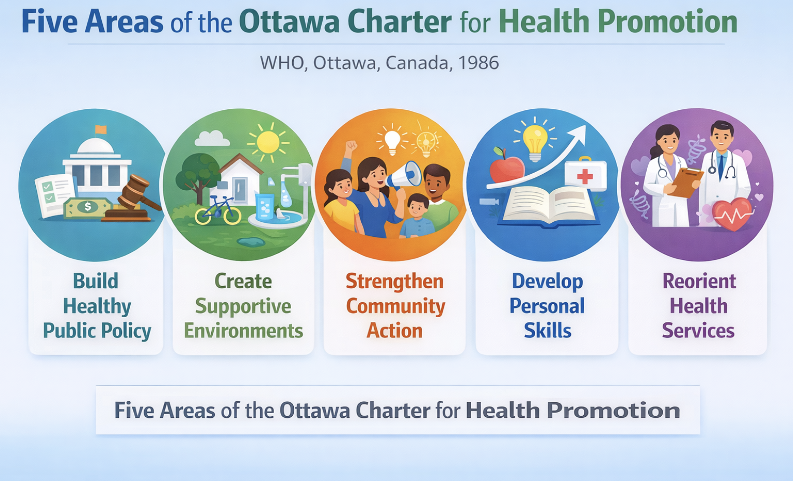

Nepal is undergoing a profound epidemiological and social transition, marked by a decisive shift from communicable, maternal, and nutritional diseases to a soaring burden of non-communicable diseases (NCDs) and mental health conditions. Driven by rapid urbanization, economic globalization, and changing lifestyle patterns, NCDs—such as cardiovascular diseases, chronic respiratory conditions, diabetes, and cancers—now account for over 71% of total deaths in the country. This structural change is compounded by an escalating mental health crisis; national data indicates that 10% of adults and 5.2% of adolescents suffer from lifetime mental disorders, alongside alarming rates of suicide and preventable injuries like drowning. From a social epidemiology perspective, these behavioral and environmental risk factors place an unsustainable economic strain on families, driving out-of-pocket health expenditures to over 54% of current health expenditure and risking catastrophic financial hardship for vulnerable populations
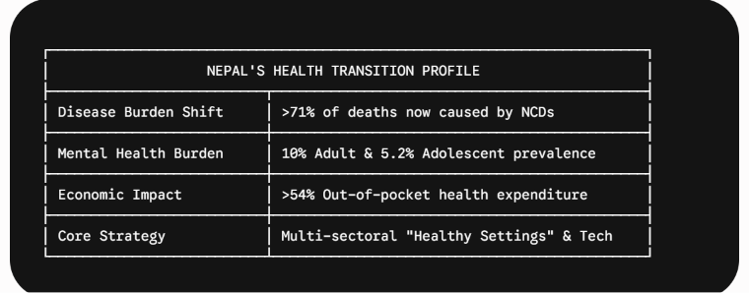
Addressing these multifaceted, lifestyle-driven challenges requires shifting public health from reactive clinical treatment to proactive, multi-sectoral health promotion. Grounded in the WHO Ottawa Charter, health promotion empowers communities by re-engineering physical and social environments where people live, learn, and work. Expanding the Healthy Settings approach across schools, universities, workplaces, and municipalities offers an effective operational framework to mitigate behavioral NCD risks and mainstream mental wellbeing. Crucially, Nepal possesses a unique "hidden shield"—centuries of Eastern wisdom (Ayurveda, Yoga, and Sowa Rigpa) and social networks (such as Guthis)—that remains underutilized in contemporary public health interventions. This national conference, centered on "Health Promotion in Digital Nepal: Harnessing Eastern Wisdom, Healthy Settings, and Innovation," addresses this gap by uniting digital tech, indigenous cultural roots, and multi-sectoral policy to chart an equitable, culturally grounded, and digitally empowered future for health promotion in Nepal.
Changing in pattern of Percentage of death attributed to different cases

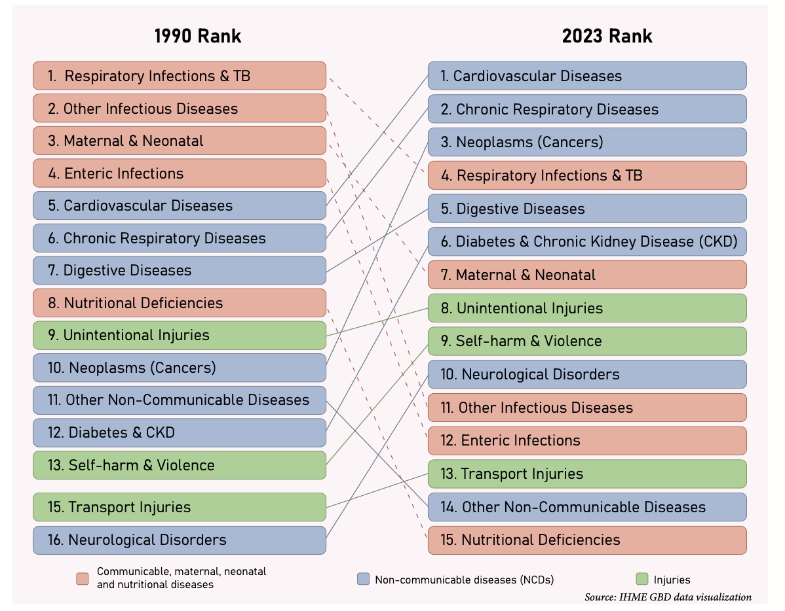
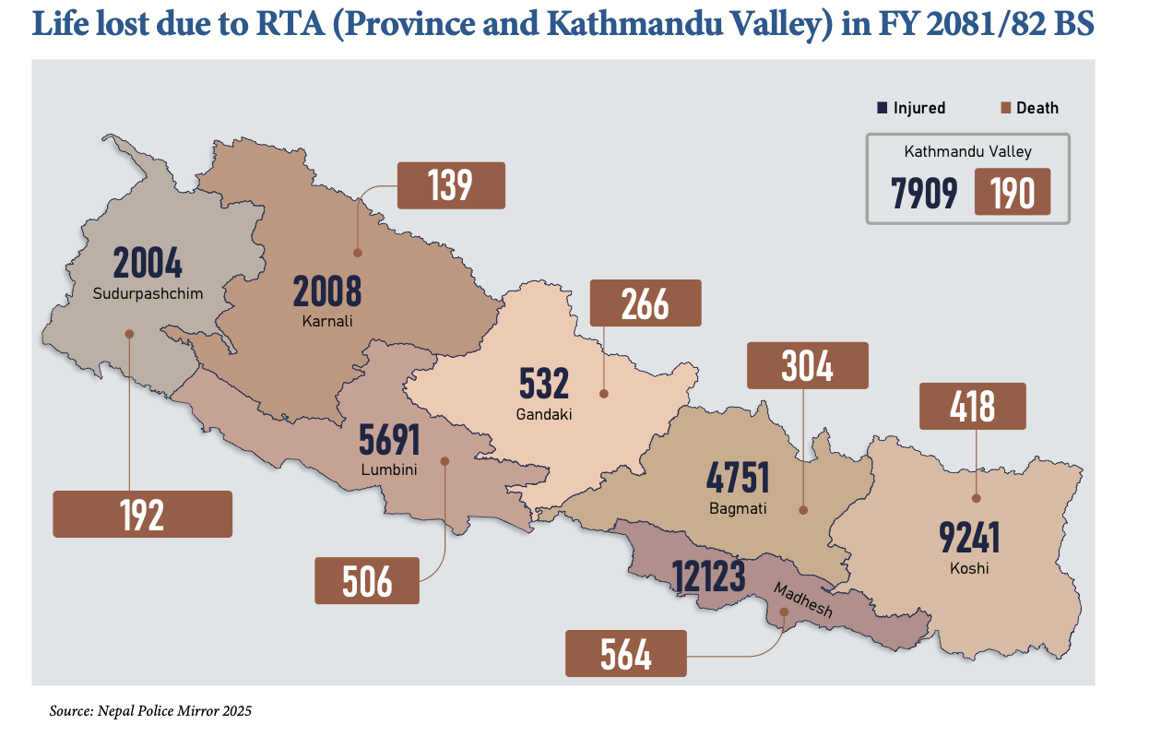

National Prevalence of Mental Disorders
Report of National Mental Health Survey 2020 with analysis of 15088 data (9200 among
adults and 5888 among adolescents) revealed that 10% of the adults and 5.2% of the adolescents had any mental disorder in their lifetime.
Major depressive disorder was found to be prevalent among 2.9% of the adults and 0.6% of the adolescents.

Suicide
Province Wise Case Registration ------------------------------------------ Total -6852
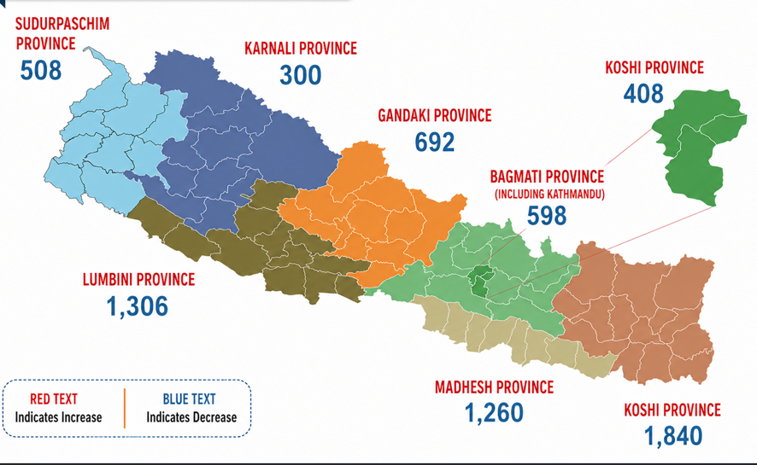

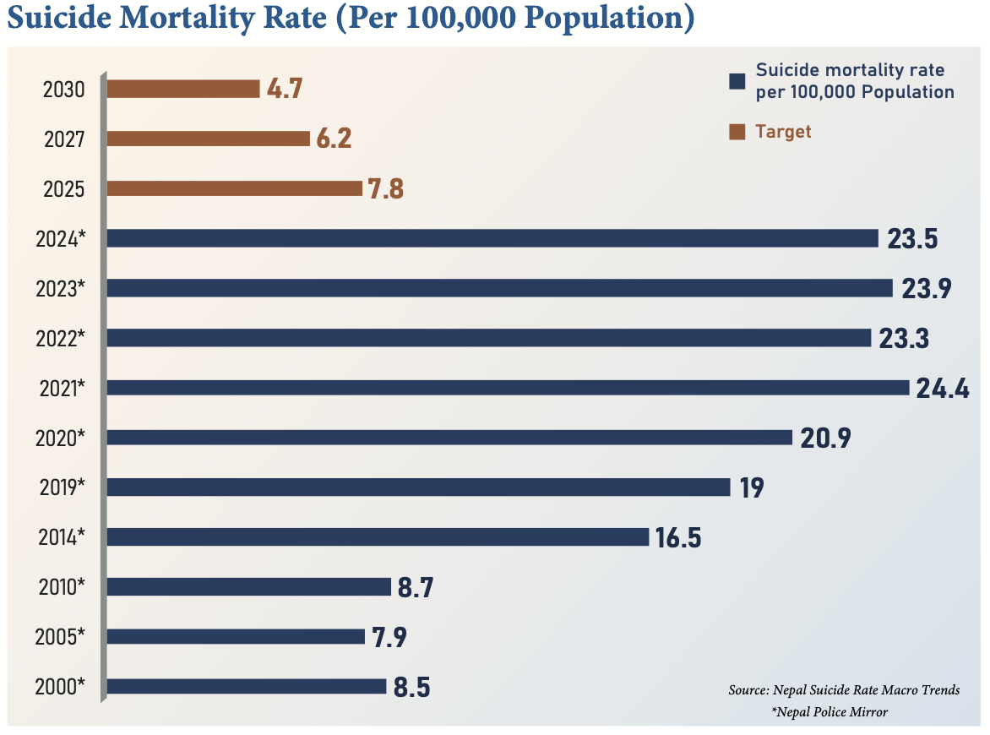

Drowning
As per WHO an estimated 1500 people drown in Nepal each year.

Non Communicable Diseases cases

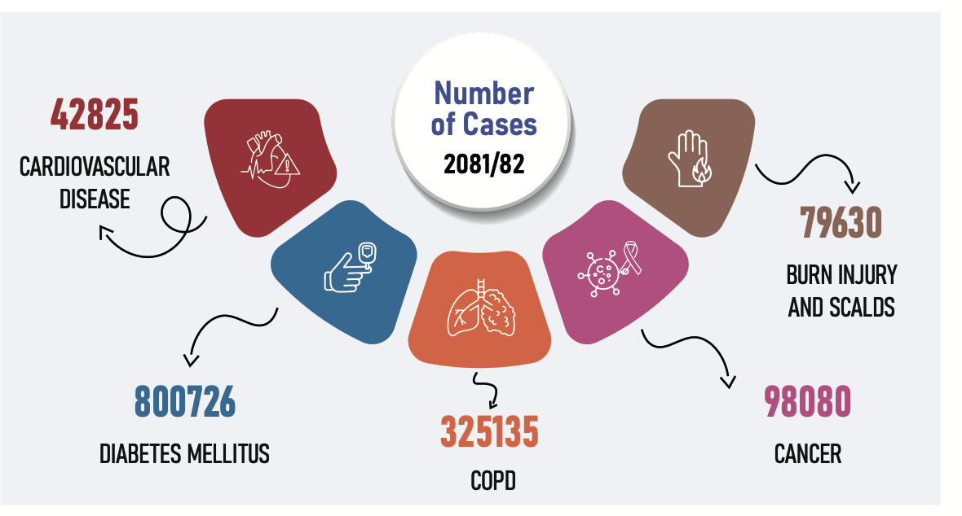

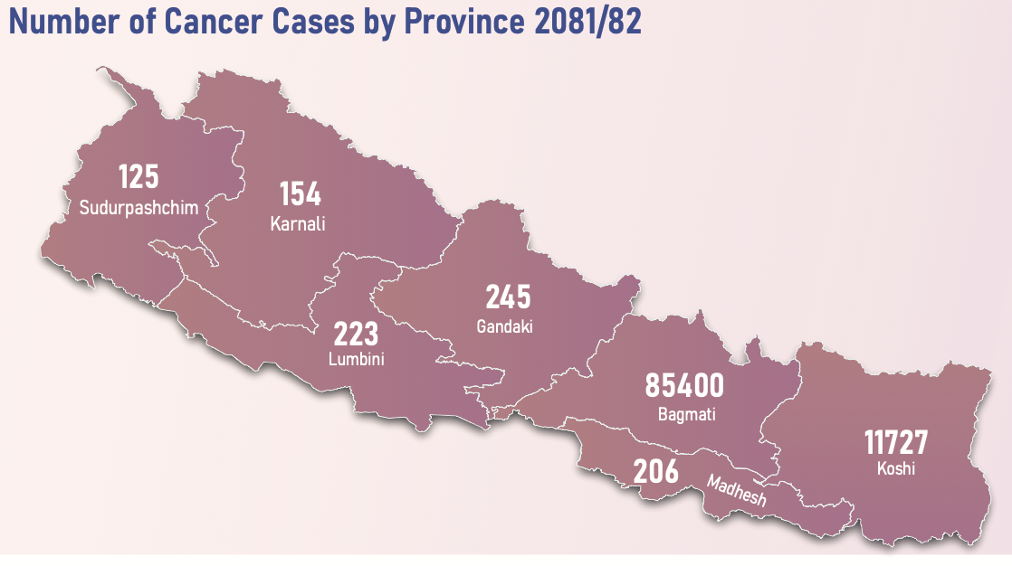
Risk factors of NCDs among adult population in Nepal
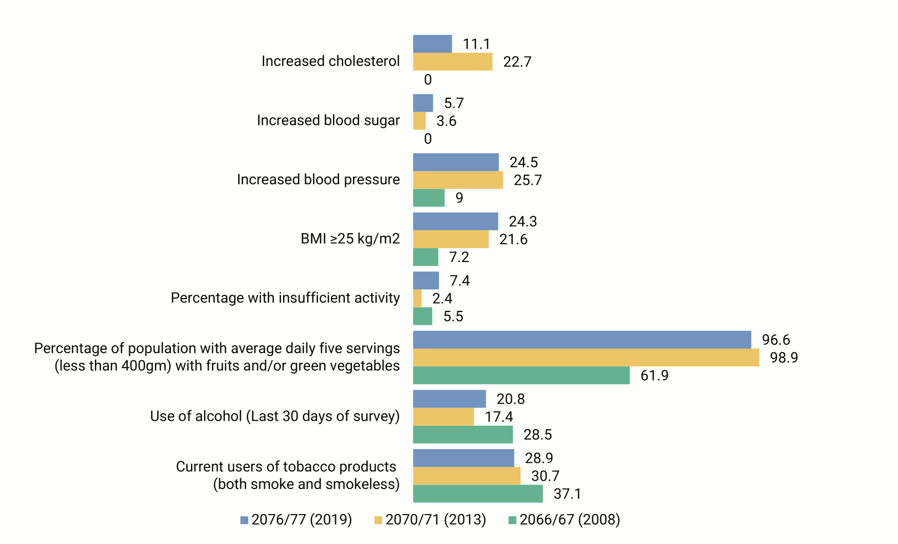

Current Health Expenditure Distribution by Diseases/Health Conditions in FYs 2018/19 & 2019/20
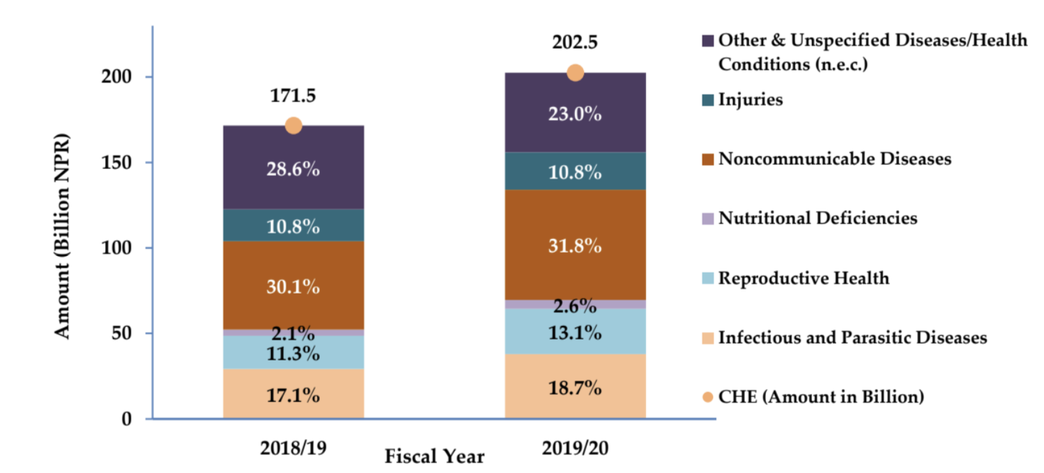
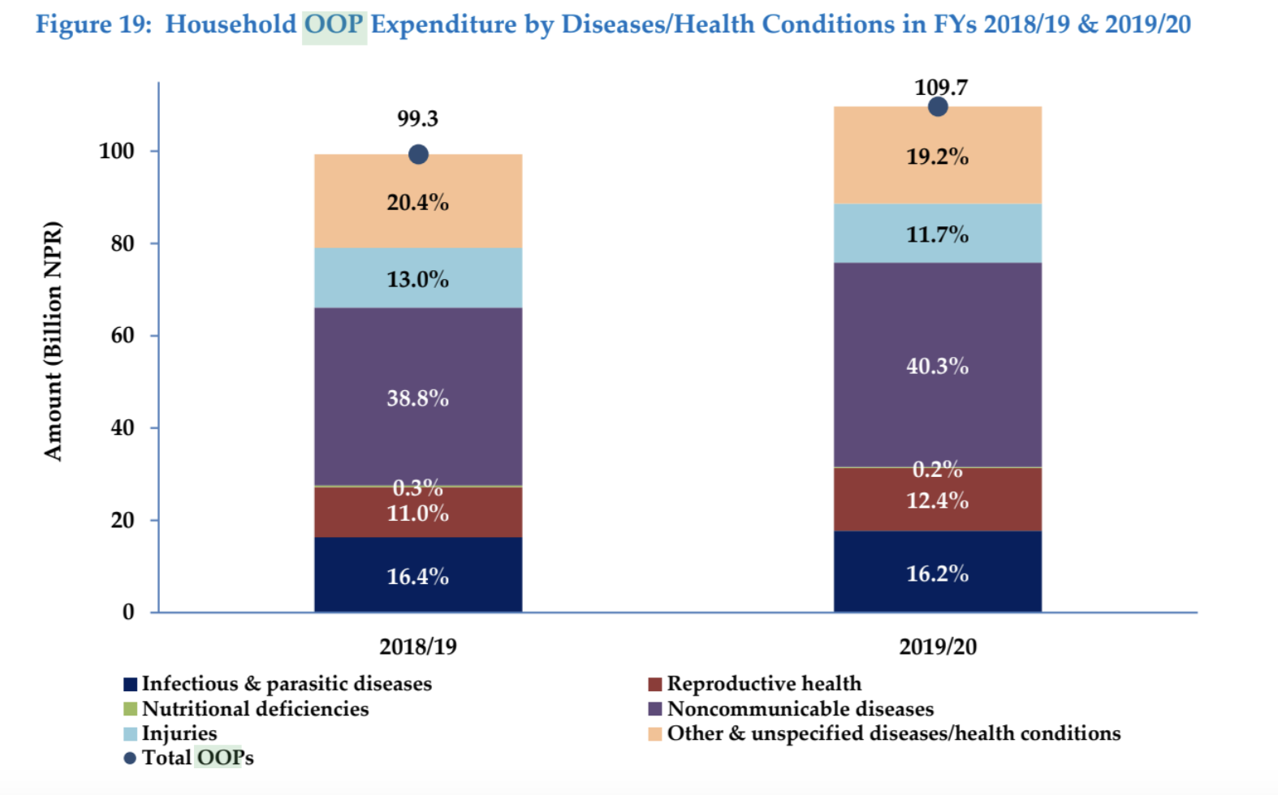

आ.व. २०८०/८१ मा ICD अनुसारका प्रमुख १० रोगहरूको दाबी संख्या र दाबी रकमको प्रतिशत
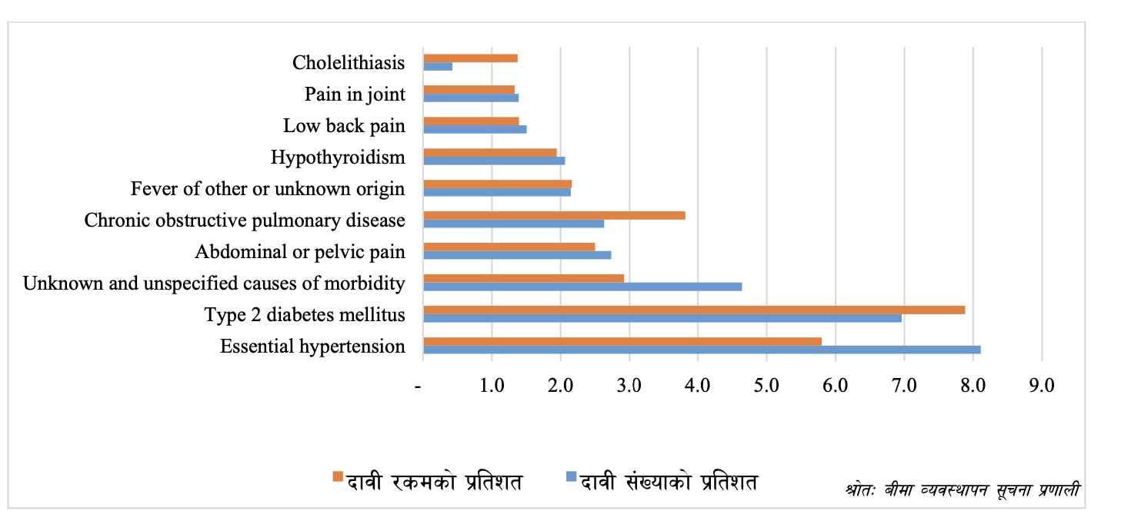

To bridge this gap, Nepal possesses a powerful "hidden shield"—centuries of Eastern wisdom, including Ayurveda, Yoga, and Sowa Rigpa (Amchi), paired with resilient, community-centric social structures like Guthis. However, these traditional systems often operate in isolation from modern digital interventions and public health frameworks.
Furthermore, true health promotion extends beyond individual behaviors. It requires Healthy Settings—embedding supportive environments within schools, universities, workplaces, municipalities, and villages. It demands the mainstreaming of mental health, moving from reactive treatment to proactive community awareness, stigma reduction, and early psychosocial support.
Addressing these interconnected challenges requires a multi-sectoral approach. Doctors, nurses, traditional practitioners, engineers, legal experts, and policymakers must collaborate to build an inclusive health promotion framework. This conference brings together tech innovation and indigenous cultural heritage to chart a culturally grounded, digitally empowered path for Health-Promoting Nepal.

Call for Abstracts

Overview
The Organizing Committee invites researchers, practitioners, and innovators to submit original research, case studies, and systemic reviews. We are looking for work that doesn't just look at "health" or "tech" in isolation, but explores the intersection of the two within the Nepali context.

Submission Categories
- Empirical Research: Quantitative or qualitative studies on health literacy or digital interventions.
- Policy & Perspective: Critical reviews of Nepal’s digital health landscape.
- Innovation Showcases: Demonstrations of apps, platforms, or community models that integrate Eastern wisdom (e.g., a meditation app in the Nepali language).

Submission Guidelines
- Abstract Length: Maximum 300 words.
- Keywords: 3–5 terms.
- Language: English or Nepali (with an English summary).
- Deadline:

2. Conference Objectives
To address these imperatives and operationalize the five thematic tracks, the conference aims to achieve the following specific objectives:
1. Leverage Digital Innovation for Health Equity (Track I):
Evaluate and showcase scalable digital solutions—including telemedicine, mHealth applications, and AI-driven hyper-local messaging in local Nepali dialects—to ensure equitable health promotion in hard-to-reach and underserved communities.
2. Build Digital Health Literacy and Counter Misinformation (Track II):
Develop multi-sectoral strategies and critical-thinking frameworks to combat online health misinformation ("fake news") while strengthening public and digital health literacy across diverse populations.
3. Integrate Eastern Wisdom and Cultural Heritage (Track III):
Examine pathways to synthesize traditional wellness systems (Ayurveda, Yoga, Sowa Rigpa) with modern public health practices, utilizing local festivals, community leaders, and traditional social structures (Guthis) to build community trust and drive behavioral change.
4. Expand Healthy Settings and Supportive Environments (Track IV):
Formulate actionable guidelines to scale the "Healthy Settings" approach across Nepal—embedding health promotion policies and physical infrastructure within schools, higher education institutions, workplaces, municipalities, and rural villages.
- 5. Mainstream Mental Wellbeing and Multi-Sectoral Capacity (Track V):
Establish strategies for community-based mental health awareness, stigma reduction, and primary care integration, while building cross-disciplinary health promotion capacity among healthcare workers, engineers, lawyers, and policymakers
Theme has been consolidated and streamlined into 5 cohesive, distinct tracks covering every single focus area mentioned.

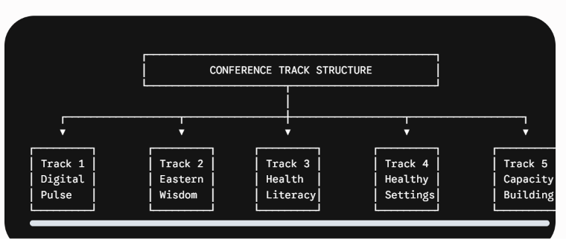
Track I: The Digital Pulse & Innovation
- Focus Areas: Telemedicine, mHealth applications, and leveraging AI for hyper-local health messaging in local Nepali dialects.
- Core Objective: Driving digital equity and ensuring modern tech solutions reach remote Himalayan communities effectively.

Track II: Eastern Wisdom & Cultural Roots
- Focus Areas: Integrating traditional systems (Ayurveda, Yoga, Sowa Rigpa/Amchi) into modern public health; utilizing community leaders, local festivals, and traditional social structures (such as Guthis) for health advocacy.
- Core Objective: Mobilizing Nepal’s "hidden shield" of heritage to ground health campaigns in community trust.

Track III: Health Literacy, Misinformation & Advocacy
- Focus Areas: Combating online health "fake news," strengthening digital and public health literacy, and advocating for structural health policy reform across sectors.
- Core Objective: Empowering citizens with critical thinking while building an advocacy framework for a Health-Promoting Nepal.

Track IV: Healthy Settings & Supportive Environments
- Focus Areas: Expanding Healthy Villages, Cities, and Municipalities; embedding health promotion into schools, universities, and workplaces.
- Core Objective: Creating physical, social, and policy environments that make healthy choices accessible where people live, learn, and work.

Track V: Mental Health & Capacity Building
- Focus Areas: Community-based mental health awareness, stigma reduction, psychosocial support, and primary care integration; cross-disciplinary capacity building for doctors, nurses, paramedics, traditional practitioners, engineers, lawyers, and policymakers.
- Core Objective: Mainstreaming mental wellbeing while equipping a multi-sector workforce to lead sustainable health promotion.

.

